**ST. BRUNO SERUNKUUMA S.S MITUJJU**

**S.1 MID TERM THREE 2023 EXAMINATIONS**

**535/1 PHYSICS (THEORY)**

**TIME: 1 HOURE 45 MINS**

**Instructions**

Attempt all questions

1. a) Write down any four branches of Physics you know. (4 marks)

……………………………………………………………………………………………………………………………………………………………………………………………………………………………………………………………………………………………………………………………………………………………………………………………………………………………………………………………..

b) What is meant by the term Laboratory? (1 Mark)

………………………………………………………………………………………………………………………………………………………………………………………………………………………………

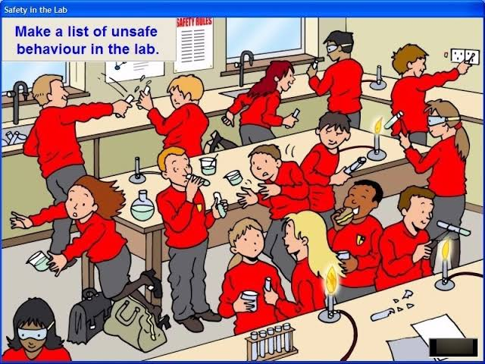c) Below is a picture of Learners in the physics laboratory. Study it carefully and identify any 5 unsafe behaviors exhibited by the learners. (5 marks)

………………………………………………………………………………………………………………………………………………………………………………………………………………………………………………………………………………………………………………………………………………………………………………………………………………………………………………………………………………………………………………………………………………………………………………………………………………………………………………………………………………………………

1. a) Define the term Area and state its S.I units. (02 marks)

………………………………………………………………………………………………………………………………………………………………………………………………………………………………

b) Find the area of the figures below

i) (2 marks)

6cm

12 cm

10cm

ii) (2 marks)

c) The school Administration is planning to install Ceramic Tiles in a classroom. Each tile measures 0.4m by 0.4m and each costs 4000 shillings. If the dimension of the classroom is 4m by 4m, Find the:

i) number of tiles needed to cover the classroom. (2 marks)

ii) The cost of the tiles needed to cover the classroom. (2 marks)

1. a) Express the following numbers in scientific notation
2. 4378 (1 mark)

…………………………………………………………………………………………………………………………………………………….

1. 0.006107 (1 mark)

…………………………………………………………………………………………………………………………………………………….

b) How many significant figures does each of the following numbers have? (4 marks)

i) 572

…………………………………………………………………………………………………………………………………………………….

ii) 0.068

…………………………………………………………………………………………………………………………………………………….

iii) 137.0

…………………………………………………………………………………………………………………………………………………….

iv) 920

…………………………………………………………………………………………………………………………………………………….

c) Identify the changes of state below. (4 marks)

GAS

LIQUID

SOLID

A

B C D

A ………………………………………………………………. B ………………………………………………….

C ………………………………………………………………. D ………………………………………………….

1. a) Two brothers were sitting in a house. They noticed that the mother was frying chicken from a kitchen that was 20m away from the house.

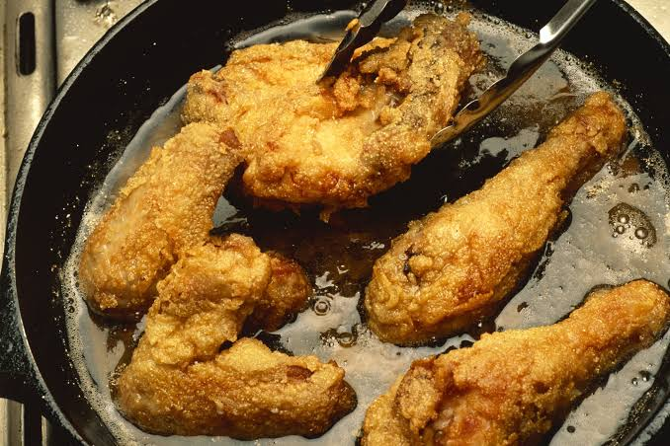

As a physics student, explain how the two brothers were able to detect the process that was taking place in the kitchen and why. (4 marks)

…………………………………………………………………………………………………………………………………………………………………………………………………………………………………………………………………………………………………………………………………………………………………………………………………………………………………………………………………………………………………………………………………………………………………………………………………………………………………………………..………………………………………………………………………………………………………………………………………………………………………………………………………………………………………………………………………………………………………………………………………………………………………………………………………………………………

b) i) A piece of a material of mass 300g occupies a volume of 15 cm3, find the density of the material. (4 marks)

ii) Given the density of water as 1.0gcm-3, State with a reason whether the material above will float or sink in water. (02 marks)

………………………………………………………………………………………………………………………………………………………………………………………………………………………………………………………………………………………………………..

1. Sylvester Sterone drives a car up a hill as shown below in the picture.

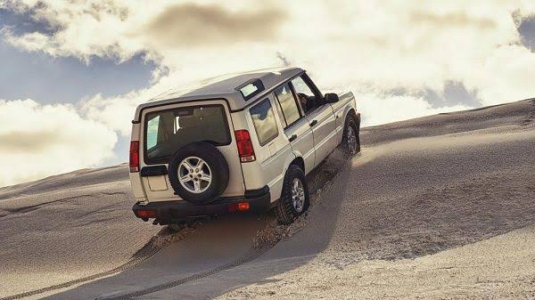

1. i) State the force that is helping Sylvester to move up the hill.

……………………………………………………………………………………………………………………………………………………………………………………………………………………………………………………………………………………………..

ii) Apart from helping his car to move, state more three uses of the force named in 2(a)(i) above.

………………………………………………………………………………………………………………………………………………………………………………………………………………………………………………………………………………………………………………………………………………………………………………………………………………………………………………………………

iii) State the effect the force named in 2(a)(i) is likely to impact on Sylvester’s car.

……………………………………………………………………………………………………………………………………………………………………………………………………………………………………………………………………………………………………………………………………………………………………………………………………………………………………………………………….

1. Apart from the force named in 2(a)(i) above, state any other five types of forces you know.

………………………………………………………………………………………………………………………………………………………………………………………………………………………………………………………………………………………………………………………………………………………………………………………………………………………………………………………………………………………………………………………………………………………………………………………………………………………………………………………………………………………………………………………………………………………………………..

………………………………………………………………………………………………………………………………………………………………………………………………………………………………………………………………………………………………………..

**END**